Rapido
Users' and developers' manual

Parts with green backgroung are useful only for developers. You can ignore them is you are a user or an administrator.

Left menu

 Share page
Select this icon to share current page by email.
Fill the recipient email address. You don't need to fill your email address if you are logged in.

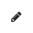 Edit page
Select this icon to edit content of current page.
You can modify content(s), add a new empty content, add an existing content, add a contact form…
You are redirected to login/create account page if you are not logged in.

 Close page edition
Select this icon when you have finished to edit current page. Don't forget to select Save changes button before closing page edition.

 Create a new page
Select this icon to create a new page.
Only the field Name is mandatory. The fields Title, Keywords and Description can be filled later , by clicking on the Settings icon.
You are redirected to login/create account page if you are not logged in.

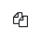 Duplicate page
Select this icon to duplicate current page.
You are redirected to login/create account page if you are not logged in.

 Versions
Select this icon to see old versions of current page and to revert to one of these versions.
You are redirected to login/create account page if you are not logged in.

 Publish page
Select this icon to publish current page. A published page can be seen and shared by everybody.
You are redirected to login/create account page if you are not logged in.

 Archive page
Select this icon to archive current page. An archived page can be seen and shared only by logged in user(s) or administrator(s).
You are redirected to login/create account page if you are not logged in.

 Settings
Select this icon to modify accounts settings, manage pages, contents and files or choose another theme.
You are redirected to login/create account page if you are not logged in.

 Logout
Select this icon to log out.

Accounts

You can create as many user or administrator accounts as you want.

A user can only manage his account in Settings - Accounts panel. He can't manage other accounts and he can't transform his account into an administrator account. Be carefull! Don't transform delete your account by error!
For each new user account, a line is added in table accounts, access_level value is set to 1 in this line.

An administrator can manage his account and all users accounts in Settings - Accounts panel. He can't manage other administrator(s) account(s). Be carefull! Don't transform your account into a user account nor delete your account by error!
For your safety, the first created account is an administrator account that can't be deleted nor transformed into a user account, it's a super-administrator account.
For each new account, a row is added in table accounts. In this row, access_level value is set to 1 if it's a user account and it is set to 10 if it's an administrator account. id value is set to 1 if it's a super-administrator account.

A visitor is somebody who is using Rapido without any account.

Accounts management:

¹ Only administrator can transform a user account into an administrator account. super-administrator account can't be deleted nor transformed into a user account.

Authors, published/archived pages

a) Authors

A page can be authorless or have one or more authors.

When a page is authorless, all logged in user(s) or administrator(s) can edit/publish/archive/delete this page, revert to another version of this page or add/remove author(s).
When a page have one or more authors, only this or these authors and administrator(s) can edit/publish/archive/delete this page, revert to another version of this page or add/remove author(s).
Creator of a new page is by default its first author.

Adding an author to a page:
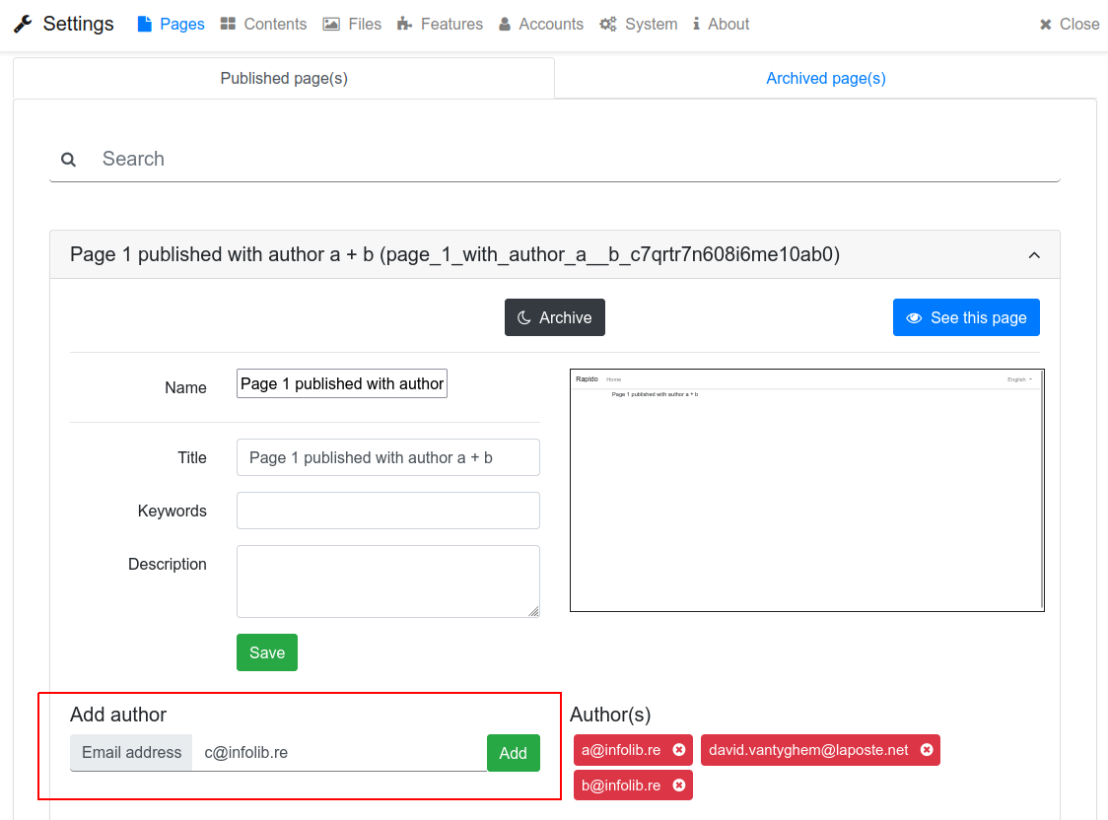

When you add an author on a page, he receives an email with an invitation to log in or to create an account.
A new row is added in table page_author. If author account already exists, account_id value is set to account id value in this row. If author account doesn't exist, account_id value is set to 0 but email value is set to author email address in this row:
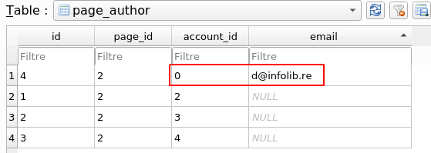

If author creates an account, he receives an email with a validation link. Or if an administrator creates author's account in Settings - Accounts panel, author only receives an information email.
In both cases, author email address is deleted in column email and his account id is added in column account_id.
See models/account/register.go and models/account/add.go.

When you delete an account in Settings - Accounts panel, it is deleted in table accounts and then, all lines in table page_author that contain the deleted account id are deleted too.

⁽¹⁾ Need verification
⁽²⁾ An author can not remove other(s) author(s) but can remove himself from a page. Be careful if you are the only author of a page!

b) Published/archived pages

A page can be published or archived.

When a page is published, everybody can see and share it.
When a page is archived, only logged in user(s) or administrator(s) can see and share it.

A new created page is by default archived. You need to publish it when you have finished to edit it:
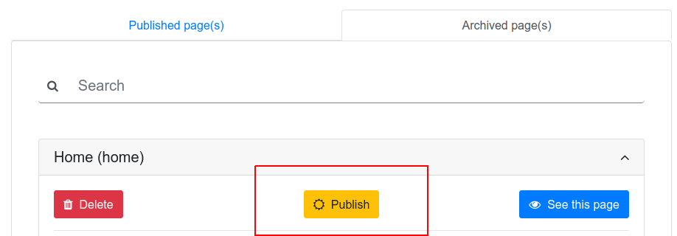

Content access rights

A content can be a normal content or a contact form.

A content is linked to a page when it's added in this page. Each content is linked to only one page.

When you add an existing content in a page or when you duplicate a page, the content is duplicated. So, you can delete a page with its contents, original contents remain in other pages.

When you add a Contact form in a page, it is duplicated in page_content table. So, you can delete the Contact form in Settings - Contents - Contact Forms panel, it remains in the page.
WARNING: if you modify a Contact form in Settings - Contents - Contact Forms panel, it will not be modified in pages that use it. You must remove the Contact form in these pages and add again the modified Contact form.
-> Rapido could be improved if Contact forms were managed like normal Contents.

In settings - Contents panel, a user can modify a content only if he have the right to modify the page linked to this content. He can't delete a content until its page is first deleted.-> need verification.

Contents not linked to a page can be modified or deleted by all logged in user(s) or administrator(s).

Uploaded files

All logged in user(s) or administrator(s) can upload a file on the server by using Rapido file manager or by editing a page. After uploading, they can use this file in contents.

Only files unused in a content can be deleted.-> à vérifier, notamment pour les pages archivées et les contenus non rattachés à une page.

a) Sorting uploaded file into categories

Rapido sorts files into categories and store them into different folders: image, video, sound, document or other.

In models/file/add_media.go, Rapido uses mimetype. It recognizes audio/mp3, OpenDocument files, MS Office files...
Rapido doesn't use these other Go modules:
- http.DetectContentType + files extensions. It considers at most the first 512 bytes of the file header and implements the algorithm described in the WHATWG MIME Sniffing standard. But it doesn't recognize image/tiff, video/mpeg, some audio/mp3 and LibreOffice files are recognized as Zip files.
- filetype. It considers only the first 262 bytes of the file header.
- MIMESniffer. It considers at most the first 512 bytes of the file header and implements the algorithm described in the WHATWG MIME Sniffing standard. It uses the GCK's file signature table. But it doesn't recognize audio/mp3 and LibreOffice files are recognized as Zip files.

b) Renaming uploaded file

- Rapido replaces some special characters by a to z A to Z
- It keeps only a to z A to Z 0 to 9 . _ - ~
- It adds _ followed by 20 aleatory characters before the dot of the file extension, or at the end of the file name if it has no extension.

See https://github.com/rs/xid
See models/file/upload_file.go

Home page

You can choose which page is home page in Settings-System-Main panel:

xxxxxxxxxxxxxxxxxxxx

Home page can't be deleted.
Home page can't be archived. If you set an archived page as home page, it is automaticaly published.

See models/page/archive.go, models/page/delete.go

Renaming a new created page

- Rapido replaces some special characters by a to z A to Z
- It keeps only a to z A to Z 0 to 9 . _ - ~
- It adds _ followed by 20 aleatory characters at the end of the name.

See https://datatracker.ietf.org/doc/html/rfc3986#section-2.3
See https://github.com/rs/xid
See models/page/add.go

Filtering email addresses in forms

It's impossible to verify email addresses syntax because of internationalization. Then, Rapido lets SMTP servers check email addresses. Rapido only test if email addresses contain @.

Rapido uses the regexp /^.+@.+$/ in:
- Account creation, login, change password: visitor, user or administrator email address. See client/src/pages/auth/Register.vue, client/src/pages/auth/Login.vue and client/src/pages/auth/password/Email.vue.
- Settings - Pages panel, adding an author to a page: recipient email address. See client/src/components/admin/Settings/Pages.vue
- Settings - Contents - Contact forms panel, adding or modifying a contact form: recipient email address. See client/src/components/admin/Settings/Features.vue and client/src/components/admin/Newcontactform.vue.
- Settings - Accounts panel, adding or modifying an account: user or administrator email address. See client/src/components/admin/Settings/Users.vue.
- Settings - System - SMTP server panel: SMTP user email address and sender email address. See client/src/components/admin/Settings/System.vue.
- Page sharing without beeing connected: visitor email address, recipient email address and sender email address . See client/src/components/admin/Share.vue.
- Using of a contact form: visitor email address. See client/src/components/global/ContactForm.vue.

Navigation menu access rights

All logged in user(s) or administrator(s) can add/move a menu/sub-menu.

Only creator of a menu/sub-menu can delete or modify it.

Pop-up messages

Pop-up messages are displayed with SweetAlert2 or with Awesome Notifications.

Miscellaneous

Displaying Golang messages with Vue, HTTP response status codes: https://developer.mozilla.org/en-US/docs/Web/HTTP/Status

HTML DOM Events: https://www.w3schools.com/jsref/dom_obj_event.asp

Files in models/xxxxx/ (excepteds in models/docs/) can be named as you want but package name must be set inside each of these files. models/blueprint.go includes some of these packages and link s their functions to API calls in Vue files.

Access rights must not be managed by Vue files but by Go files and by models/blueprint.go.

